## **Exercise 3: Stored Procedure**

## **Scenario 1: Process Monthly Interest for Savings Accounts**

### **Objective**

Create a **stored procedure ProcessMonthlyInterest** that:

* Finds all **Savings accounts**
* Increases their balance by **1% interest**
* Updates the balance in the Accounts table

## **Approach**

* Use a **FOR loop** cursor to select all Savings accounts
* Apply 1% interest (balance = balance + 1% of balance)
* Update each account’s balance
* Commit changes
* Display a success message using DBMS_OUTPUT.PUT_LINE

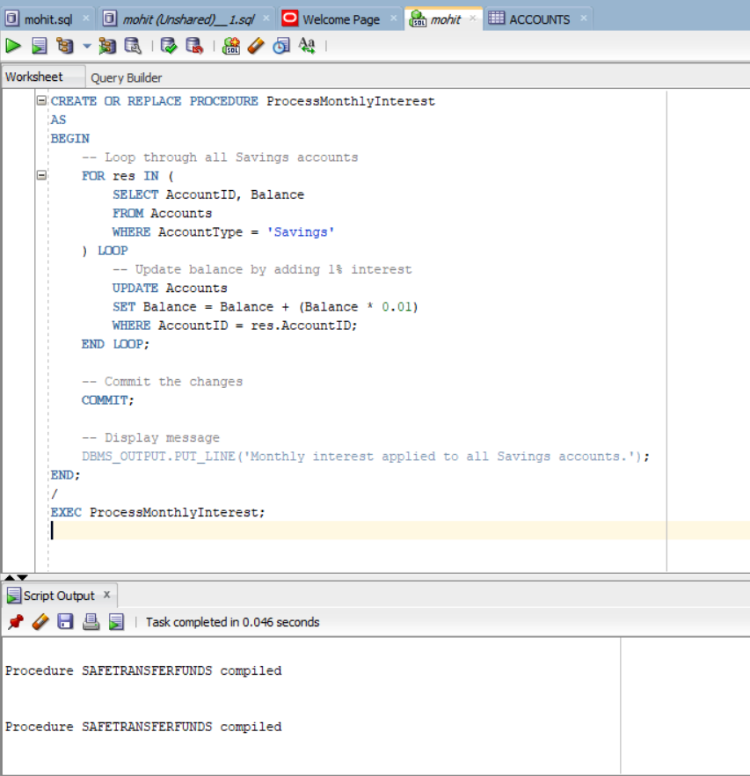

## **How to Call the Procedure**

EXEC ProcessMonthlyInterest;

## **📊 ✅ Expected Behavior**

|  |  |
| --- | --- |
| **Account Type** | **Action** |
| Savings | Balance increased by 1% |
| Other types | No change |

And in the **DBMS Output**:

Monthly interest applied to all Savings accounts.